INTRODUCTION TO GENERATIVE ARTIFICAL INTELLIGENCE
CSET – 419

Project Report

FINVEXIS AI
AGENTIC BUSINESS INTELLIGENCE PLATFORM

Team Members:
Robin Singh(E23CSEU1166)
Riya Garg (E23CSEU11XX)
Shubham Pandey(E23CSEU1167)

- Introduction
There are many companies that engage in various industries like Human Resources, Sales and Finance. All of these businesses are backing an enormous amount of data that need to analyse and make decisions on a continuous basis. With the traditionally used BI solutions (i.e., manual reports, a variety of separate tools, and static dashboards) limiting the ability to obtain these insights in a real-time manner, these solutions also require a large number of Human Resources.
Finvexis AI project introduces a multi-functional, agent-based Business Intelligence platform that will help automate Financial Analysis, HR Operations, Sales Intelligence and Strategic Reporting. The system is organized into modular components where each component is assigned a set of agent-based AI capabilities. As such, there will be an ability to seamlessly process complex and simple queries using natural language for each area of business.
Each area of business (i.e., Finance, HR, Sales, etc.) will operate as a separate module with its own workflow and data pipeline. For example, the Finance module will allow users to process invoices, audit vendor records/roles, analyse their budgets and so forth; while the Sales Module will provide users with support for their CRM, lead scoring, HR Policies and Resumes. The Business Intelligence Module will allow for users to track KPIs, forecast and provide strategic recommendations.
1.1. Goal and Objectives of the Project:
- Automate the financial, human resources, and all other business workflows by developing agents to perform tasks that were historically performed by Human Resources
- Provide users with the ability to access business data through Natural Language without requiring users to have a technical background in order to do so.
- Quickly identify anomalies, compliance risks, and budget variances through the use of automated processes.
- Enable multiple Agents to collaborate on multiple areas of business.
- Create a modular architecture that is production ready and able to expand beyond the functional areas currently included in this project.
- System Architecture
The system consists of three independent modules or platforms - Finance, Sales/HR, and Business Intelligent. Each module has an orchestrator, agents, and methods of handling data, so they can work independently of one another while still cooperating when necessary. All three modules are connected to each other by a single API gateway that routes requests from the front-ends to the appropriate departments.
2.1 - High Level Architecture
The system follows a straight-forward flow at high level:
- The front-end (using React / Next.js) takes in user input
- The FastAPI Gateway receives a request.
- The request gets routed to the appropriate Orchestrator.
- The Orchestrator calls the required agents.
- The agents gather/process data from the data layer.
- The response is sent back to the front-end.
All departments follow the same structure of:
- Orchestrator -- Responsible for deciding what the action is;
- Agents -- Do the actual work;
- Data Layer -- Store/retrieve the data needed for the task
This Modular design provides extensibility.
- Finance Department
The Finance Module is Finvexis AI Software Automated Accounting / Compliance Division. It uses a shared Data Base (DB) to operate on a Primary Invoice Data (ex. Q1 2026).It consists of four distinct Agents (the Invoice Agent, Auditor Agent, Vendor Intelligence Agent and FP&A Agent). All Core Financial Logic, Tax Rules and Alert Thresholds are processed through an underlying deterministic set of engines, leaving only the ability of the LLM to generate a Report Narrative from the static data.
3.1 Execution & Orchestration Flow
The Finance Module requires strict sequential orchestration for data dependency reasons as compared to Business module's parallel processing of independent tasks. Thus, the Orchestrator enforces a fixed order of operation: Invoice → Auditor → Vendor Intelligence → FP&A.
This order is critical as the Invoice Agent is the Data Entry Layer. In order to guarantee that a newly uploaded invoice is parsed & recorded in the Ledger prior to the Auditor or Vendor Agent beginning their System Wide Scans, the Orchestrator forces execution by scheduling prior to the completion of any execution of the other agents.
If a Complex User Query triggers multiple agents to run, the Orchestrator will execute the agents in sequential order – allowing for the failure of any single agent to not terminate the entire execution pipeline – and synthesize the independent results from all of the agents into one complete result.

3.2 The Invoice Agent (Data Ingestion Layer)
The Invoice Agent will be the first point of entry for any new financial data. It will process PDF files that are uploaded, retrieve structured information from the file, and apply rigorous rule-based taxation logic (e.g., determining where GST should be applied, determining whether TDS has been applied correctly). It will also screen the document to identify immediate, basic risks prior to submitting the validated invoice into the common system ledger for formal entry.
3.3 The Corporate Auditor Agent (System Level Analysis)
The Auditor Agent will provide a macro-level analysis of invoices, using the shared ledger as a source of information. It will allow users to filter the shared ledger based on the time range they wish to analyze (e.g., historic month or quarter), aggregate totals, and confirm prior and current spending patterns. In addition, the Auditor Agent will utilize only deterministic logic (i.e., the Auditor Agent will not employ LLM guessing), to identify systemic anomalies such as duplicate invoice submissions; the absence of applicable GST; abnormal or sudden increases in expenditures; and abnormal price discrepancies.

3.4 The Vendor Intelligence Agent (Risk Assessment)
The Vendor Intelligence Agent analyses the actions and behaviours of Vendors to ensure the organization can manage its supply chain as well as ensure vendor compliance. The Vendor Intelligence Agent has two main functions, the agent can either create an in-depth profile of an individual Vendor or perform a risk comparison of all Vendors that are active within the organization. The agent uses historical patterns to determine the overall risk associated with a Vendor; for example, if there were patterns of GST non-compliance for the Vendor, stealthy price increases, and atypical concentrations of spending.
After the analysis is complete, the Vendor Intelligence Agent will generate a Quantitative Risk Score (0 -100), as well as assign a Severity Rating for each Vendor.

3.5 The FP&A Agent (Budgeting and Forecasting)
The FP&A Agent continually monitors the allocation of internal resources (Departmental budgets) by constantly comparing Actual vs Budgeted spending on a Departmental level and tracking the overall burn rate to project when budget overruns may occur.
One of the major features of the FP&A agent is "What-If" simulations. For example, if a user were to ask "What if IT were to spend another ₹1,00,000?", the FP&A Agent would create a model for the hypothetic expenditure. The final decision to approve or deny the proposed expenditure would be made solely by the deterministic budget engine where financial safety constraints have been adhered to, with no reliance on LLM-based decision-making.
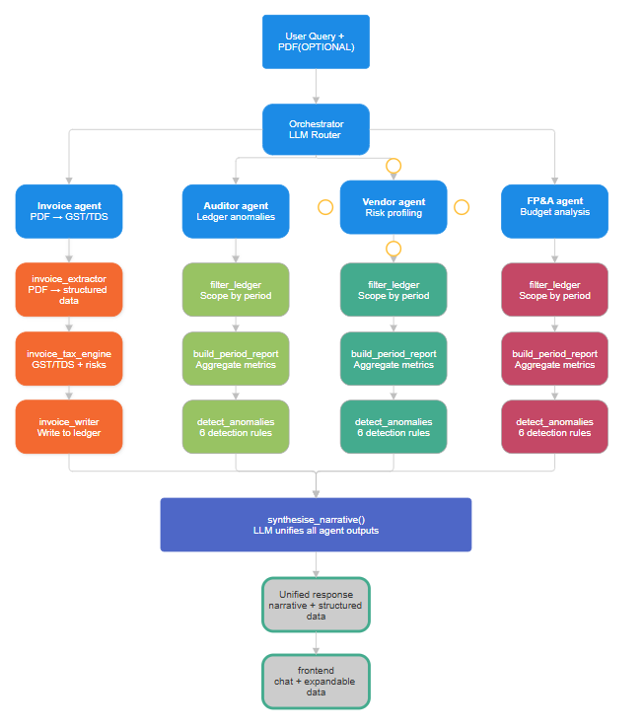

- Sales and HR Department

4. The Sales and Human Resources Module
The Sales & Human Resources (HR) module is a singular, goal-driven tool to help streamline client acquisition and internal employee management. There is no need to navigate through multiple disconnected systems; rather, the system utilizes Natural Language Processing (NLP) as a sophisticated technique that processes requests submitted using natural language (NLP) with or without accompanying file attachments, and automatically determines the appropriate agent (existing system component) to process the request.
4.1 System Flow and Intent Routing
The framework for this module is a dynamic routing pipeline developed from the following four stages:
1. Query Ingestion: The user submits a request (i.e. “Draft a follow-up email for Acme Corp.” and “Evaluate the resume of this candidate.”)
2. Intent Classification: The routing engine will analyze the semantic intent of the user request and determine the necessary business unit domain context for routing the user's request.
3. Agent Routing: The routing engine will automatically route the user's request to the correct agent (i.e. CRM, Sales Insights, Sales Advisor or HR) that will fulfill the user's request based on the user request provided.
4. Processing & Synthesis: The request is processed by the agent through the use of database queries, mathematical operations, or retrieving of documents from the agent’s respective database(s) and the returned response to the user is presented as a single coherent product.

4.2 The CRM Layer (Customer Data Management)
At the base of all Sales Systems is a localized (as opposed to distributed) CRM database management system that runs using an SQLite DBMS. All of the CRUD (Create, Read, Update, Delete) database operations are performed programmatically from this layer. The Layer will not only support traditional records management functions; it will also support a chronological ledger in order to capture and store an ongoing historical record of any type of interaction (e.g., telephone calls, emails, meetings, etc.) with the customer and the company along with supporting the historical records for each customer.

4.3 Lead Scoring and Pipeline Analytics
This module consists of 2 strictly deterministic analytic agents to help maximize the sales team's efficiency:
Lead Scoring Agent - This agent evaluates prospects by using quantitative measures to help identify high-value targets. The Lead Score is calculated from various weighted criteria, including prospective client's budget, size of prospective company, the level of involvement of decision-makers within the prospective company, and the historical engagement with that prospective company. The results will be a priority list along with immediate tactical next steps.
Sales Insights Agent - This agent is a diagnostic engine for the sales pipeline, using information from the CRM database, the Sales Insights Agent computes key performance metrics for the sales team such as conversion rates for leads, deal velocity from lead to close, and historical win/loss tracking. All of the mathematical calculations and identification of sales bottlenecks will be conducted through deterministic Python logic. The large language model (LLM) will only be used to convert the hard metrics developed through deterministic Python logic into text- readable performance metrics.

4.4 The Sales Advisor Agent (Generative Execution)
The Sales Advisor Agent is driven by AI generative, LLM technology with the explicit purpose of executing sales on behalf of clients or potential clients in a manner that is as personalized and relevant to that particular contact as possible using their CRM data and any other information available to the Sales Advisor Agent.

4.5 Human Resources and Recruitment Systems
The HR sub-system utilizes the same architecture as Sales; however, the constraint has been shifted from compliance within the organization to acquiring and maintaining talent through two different types of technology.
4.5.1 Policy Retrieval Utilising RAG Architecture In order to manage corporate compliance and handle employee questions related to employee policies, corporate policy documents are deconstructed, embedded, and stored in a Vector Database. When an employee asks a question that is related to a policy, the sub-system performs a similarity search against the policy document chunks contained within the VDB and retrieves the appropriate chunk of policy to restate back to the employee based only from the context of what has been provided via the retrieval process. Consequently, there is no opportunity for AI to “hallucinate” or for the AI to misrepresent company policy as a product of the LLM considering anything outside of the goal of completing the employee's answer accurately based on policy document retrieval and context.
4.5.2 Resume Evaluation Engine To speed up hiring, the Resume Evaluation Engine reads resumes (usually in pdf) that candidates submit and mathematically compares those resumes to job descriptions. The Engine has the ability to identify relevant data from the resumes such as skills, years of experience, and education and then compare that against the items outlined in the job descriptions as required competencies. The Resume Evaluation Engine produces a deterministic match score (0 - 100) for each candidate and highlights the candidates' deficiencies compared to the job descriptions and provides the hiring manager with a standardized and objective way to evaluate the candidate.
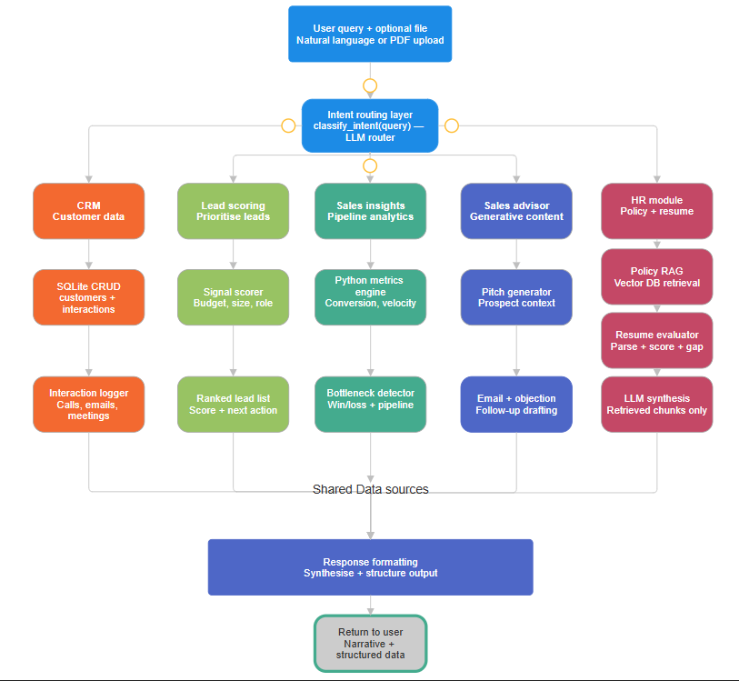
- Business Intelligence Department
Whereas the Finance and Sales categories of the system are concerned with executing against their respective departmental mandates and compliance requirements, the Business Intelligence (“BI”) module operates at an overall, macro-strategic level for the company as a whole (or “entire enterprise”). The BI system uses past business activity (as captured in CSV files) from within the organization and pairs that data with external market information to determine what has been done in the past, what will likely happen in the future, and what executive-level actions are needed for improvement.
5.1 Data Processing & Orchestration in Parallel
Before any analysis can occur, we must first pass the raw input data that will be analysed through a rigorous preprocessing pipeline. In this process, we standardise datetime format; we chronologically order the records; we linearly interpolate to populate missing values; and we remove duplicate records in preparation for creating an unspoiled time series database for the analysis.
To reduce latency in calculation, the BI Orchestrator will leverage a ThreadPoolExecutor to run these calculations with a hybrid of concurrency/parallelism and sequence:
- Concurrent phase: when the KPI Agent and the Forecasting Agent are kicked off and executed concurrently because they only process historical data and do not depend on one another for processing.
- Sequential Phase: when the results from the concurrent phase are sequenced into the Market Agent (which requires internal KPIs to compare against competing external organisations' KPIs) and the Strategy Agent provides the final summary of the data analysis.
5.2 The Key Performance Indicator (KPI) Agent
Operating on strict deterministic logic, the KPI Agent evaluates the company's financial and operational health without relying on LLM-driven assumptions.
- Growth & Margins: This determines the Period over Period Revenue Growth & Expense Growth rates.
- Unit Economics: This compares the efficiency of marketing by comparing CAC (customer acquisition cost) to LTV (customer lifetime value). The LTV of a customer is calculated using the formula: LTV = ARPU / Churn Rate
- Anomaly Detection: The Kpi Agent uses a rolling 5 period Z-score method to detect anomalies. For example, the Kpi Agent will detect and flag any statistical anomalies that will require executive oversight if $|Z| > 2.0$ for any metric.
- Composite Health Score: The Kpi Agent calculates a Composite Health Score (0-100). Each of the variables listed above is normalized and weighted to compute an overall business health score.
5.3 The Forecasting Agent (Predictive Analytics)
The Forecasting Agent applies statistical modeling to predict future business trajectories. It primarily utilizes Linear Regression ($y = mx + c$) across revenue, expenses, and churn metrics to project performance over a forward-looking 12-month horizon.
To account for market volatility, the agent does not output a single static prediction. Instead, it generates three distinct scenarios:
- Realistic Forecast: This is simply the underlying prediction of the linear regression;
- Best Case Scenario: This assumes a positive variance of +15% versus the predicted linear regression projection.
- Worst Case Scenario: This assumes a negative variance of -15% versus the predicted linear regression projection due to an economic downturn or significant increased competition.
Each projection comes with a mathematically derived confidence score, which evaluates the amount of historical data available (Size Factor), relative to the amount of instability in the available data (Coefficient of Variation). Therefore, if the historical data used to develop the projections yield a very unstable confidence score, the user may want to consider their developing projections are not reliable for actual decision-making purposes.
5.4 The Market Agent (Competitive Intelligence)
This agent evaluates a company's performance based on Key Performance Indicators (KPIs) compared to the industry at large.
- Pricing index: The agent uses an average price of a company to find a Pricing index by comparing the average price of the company to the industry's mean price for that type item.
- Market Positioning Score: The agent computes a company’s market positioning score based on an algorithm that weighs features covered by the company relative to other companies (features covered) relative to the total amount of the TAM for that item/feature.
- Opportunity Scoring: The agent determines an opportunity score based on the number of features that the top competitors in that market are currently covered by versus how many features are currently available from the company. This score helps identify the most attractive future product opportunities for the company to develop within their TAM.
5.5 The Strategy Agent (Apex Decision Layer)
5.5 Strategy Agent (Apex Decision Layer)
The Strategy Agent builds on top of all the BI pipeline agents powering it up with its own use of LLM technology. The Strategy Agent takes all the previous agents' outputs (numbers, anomalies, forecasts, etc.) and synthesizes them into a single multi-timeframe strategic roadmap.
Deterministic Fall-Back Logic
The Strategy Agent has a deterministic fallback to ensure that its operational continuity can be maintained if the LLM API becomes unavailable. The following is an example of one type of deterministic fall-back:
- Margin Trigger: If the Net Margin falls below 10%, then automatically the system will proactive trigger a “Cost Optimization” protocol and establish a SMART goal to reduce G&A costs.
- Churn Trigger: If the Churn Rate exceeds 8%, then the system will require creating a Customer Retention Program.
- Expansion Trigger: If the Opportunity Score is highly favorable, then the system will recommend expanding the features to capture additional market share.
Regardless of whether it is using the LLM or the deterministic fall-backs, the Strategy Agent's final output will ensure that all business weaknesses are matched with an actionable measure.
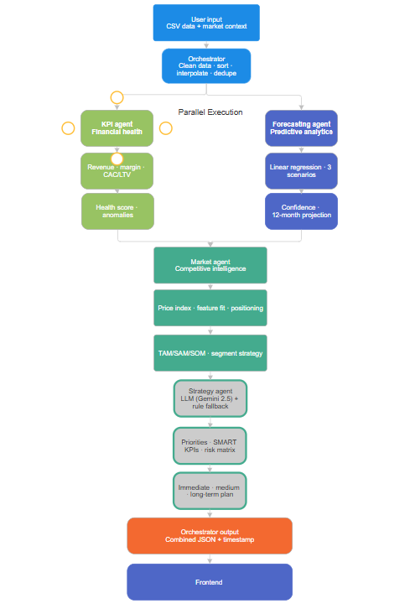
- Results and Demo

- Future Scope
Currently, Finvexis AI operates as an effective multi-agent system with a strong deterministic approach. Over time the system should scale to accommodate larger business operations. The first step in meeting this goal will be the migration of the architecture from a centralized SQLite database architecture to a distributed relational and vector database architecture (e.g, PostgreSQL and Pinecone) to enable real-time, two-way API integrations with mainline ERP and CRM applications like SAP and Salesforce.
In order to support high levels of concurrency, and mitigate processing latencies, the entire monolithic orchestration will be containerized into microservices managed by Kubernetes, using an event-streaming message broker (e.g., Apache Kafka ).
In addition, the application will utilize a Routing Model in a platform agnostic way for the dynamic routing of complex strategic tasks to 'frontier reasoning' models (e.g., o-series or Gemini 1 5 Pro) and localized fine-tuned models for quick operational queries.

- Limitations
All data associated with INVOICE_LEDGER will be reset once an application is restarted; plans are in place to implement a persistent backend using either SQLite or PostgreSQL for production purposes.
- The only date range that is currently supported by our application is Q1 2026; the capability to perform multi-year analysis and rolling window comparisons does not exist at this time.
- All department budgets are hardcoded at the present time. FP&A budgets are defined in the file dummy_data.py; a budget management interface will need to be built for actual deployment.
- Currently there is no method for authenticating an API call in the current API Interface, therefore, there are currently no restrictions on accessing any Endpoint. When we do deploy to an external environment we will require either: JWT or API Key authentication to be established before any external deployment can take place.
- The current functionality of the invoice tax engine will assume that all sales will be charged GST at an 18% rate regardless of what type of good/service is being sold. Different types of services that incur different GST rates that are not currently represented within the invoice tax engine (e.g., 5%, 12%, 28%) will need to be added to the invoice tax engine in the future.
- LLM structured output reliability — Groq's llama-3.1-8b-instant occasionally returns malformed JSON for complex invoice schemas. Resolved by adding a fallback JSON parser that strips markdown fences and handles nested string fields.

- Conclusion
Finvexis AI shows how it's possible to create a multi-departmental-agent-smart-AI-platform (like an AI-powered platform) with clearly defined logical and execution paths of determinable business logic versus “narrative” driven by an LLM (language model).
An LLM is used only for restating factual information that it finds—no direct role in risk assessment or financial decision-making—and is separate from the deterministic logic of the business application for internal accounting (Python) to enable auditability, testability, and reliability that are difficult/impossible on purely LLM-driven approaches.
The four agents in the finance department demonstrate how each agent can be separately tested and proven, every function of the engine returns deterministic values, and the LLM layer can be changed or upgraded without adversely affecting analytical logic.
The modular nature of the platform allow for easy integration of additional business models without changing the existing ones. This same model of deterministic engines and constrained LLM narration can be replicated in the sales/hr and BI departments and will work with all future departments added to the system.

